INTRODUCTION:
M/s Hind Energy & Coal Beneficiation (I) Pvt. Ltd, (HECBIPL) has been established in the year 2005 when a Coal beneficiation plant with capacity of 2.4 MTPA was set upat village Hindadih, Tehsil Masturi, District Bilaspur (C.G.) The raw coal is received generally from SECL Dipka mine which is about 70km from HECBIPL.
Coal beneficiation is the process for cleaning & reducing ash content in the coal, thus improving the quality of coal. This is a dry type of coal Washery, having obtained environmental clearance vide letter No J-11015/190/2007-IA. II (M) dated 24/06/2008.
MoEF has given extension for Railway siding till March 2014.
EC compliance with monitoring reports for the period of July 2012 to December 2012 is enclosed
S.No. | Specific Conditions | Action Taken
1 | The raw coal, washed coal & coal wastes (rejects) shall be stacked properly at earmarked sites(s) within stockyards with wind breakers / shields. The storage time capacity of  the stockyard shall be to store for not more than one day. Adequate measures shall be taken to ensure that the stored materials do not catch fire. | Raw Coal, Washed coal & coal waste (rejects) stacked properly at earmarked sites(s) covered with boundary walls. Water Sprinklers are provided on the coal stock to reduce dispersion of coal particulate matter in ambient air. This also helps minimizing risk of coal storages fire. (Refer AnnexureI)
2 | Hoppers of the coal crushing unit and washery unit shall be fitted with high efficiency bag filters/dust extractors and mist spray water sprinkling system shall be installed and operated effectively at all times of operation to check fugitive emissions from crushing operations, transfer points of belt conveyor systems which shall be closed and from transportation roads. | Coal crusher and coal pulverizer of the plant are facilitated with Bag filters of adequate capacity and efficiency so as to comply with particulate emission norms. Mist spray water sprinkling system is provided. Closed conveyor system is provided to prevent fugitive dust emissions. (Refer AnnexureII)
3 | All internal roads shall be concretized. The roads shall be regularly cleaned | All internal roads are concrete & plantation has also been done along
 | with mechanical sweepers. Avenue plantation developed along the roads. | the road side wherever possible. (Refer AnnexureIII)
4 | The company shall prepare the plan for transportation for raw coal & | Land has been acquired for Railway siding. DPR & Drawings have already
 | coal rejects by rail integrating it with the plan of M/s. South Eastern Coalfields. | been submitted to South Eastern Central Railwaysforapproval.It is under active consideration.
5 | The company shall obtain prior approval of SGWB/CGWB Regional office for | Necessary permission from CGWB is already obtained is enclosed herewith  (AnnexureIV Letter No. 145/2012 dated 23.04.2012)
use of groundwater for the Washery
operations.
6 | Industrial wastewater (workshop and wastewater from the washery) shall be properly collected, treated so as to  confirm to the standard prescribed under GSR 422 (E) dated 19th May’ 1993 and 31st December’ 1993 or as  amended from time before discharge. Oil and grease trap shall be installed for workshop effluents | Effluent treatment plant has been constructed and the treated effluent is confirming with CECB standards.
7 | The unit shall be a zero-discharge facility and no water shall be discharged from the washery into the drains / natural water sources. Recycled water shall be used fordevelopment& maintenance of green belt and in the plant operations. | Zero discharge is strictly followed and all the treated water is being utilized for green belt within the premises. No  wastewater is discharged into drains / water resources.
8 | Green belt shall be developed along the area such as the washery unit, crushing unit & stockyard. | Already 3000 sapling have been planted, at washery, crushing plant & storage yard. Some of the saplings are growing fast in to becoming trees.(ReferAnnexureV)
9 | Railway siding shall be established at Gatora Railway stataion and at hathbandh. Railway siding at a distance of 10km & 30km respectively, thereafter coal (raw and  washed coal) would be transported by rail from these  siding within 3 years. | Already 25.86 acres of land has been acquired for this purpose. DPR is already approved by SECR. As per earlier EC, Railway siding was to be completed in 3 years time. However due to pending of some policy decisions by Ministry of Railways the railway siding could not be implemented. Accordingly HECB has requested MoEF to kindly consider to give extension for railway siding till March, 2014.This issue has been discussed in the EAC meeting and MoEF has given extension for Railway Siding till March 2014. (ReferAnnexureVI)
10 | Solid wastes and stones shall be backfilled into the murrum mine leases as part of its Mining Plan. | Filling of murrum in mine lease area is being done

General Conditions:
S.  No. | General Conditions | Action Taken
1. | No change in technology and scope of working shall be made without prior approval of MOEF | Noted and complied.
2 | No change in the calendar plan for washing the quantum of mineral coal & waste produced shall be made. | No change in the calendar plan
3. | Four ambient air quality monitoring stations shall be established in the core zone as well as in the buffer zone for SPM, RSPM, SO₂&NO_{x} monitoring. Location of the stations shall be decided based on the meteorological data, topographical features and environmentally & ecologically sensitive targets in consultation with the State Pollution Control Board. | Four nos. of ambient air quality monitoring stations have been established in consultation with SPCB & are operational for monitoring ambient air data. The data for July 2012 to December 2012 is enclosed along with EC Compliance.
4. | Fugitive dust emissions (SPM and RSPM) from all the sources shall be controlled regularly monitored and datarecorded properly.  Water spraying arrangement on haul roads, wagon loading, and dump trucks (loading and  unloading,) points shall be provided and properly maintained. | Fugitive dust emissions are restricted, Water spray arrangement has been provided on the roads, loading & unloading points.
5 | Periodic monitoring report with data on ambient air quality (SPM, RSPM, SO₂ and NO_{x}) shall be regularly submitted to the ministry including its regional office at Bhopal and to the state pollution control board and the central pollution control board once in six months. | The periodic monitoring report has been prepared and submitted to RO, Bhopal reports enclosed
6 | Adequate measures shall be taken for control of noise levels below 85 dBA in the work environment workers engaged in blasting and drilling operations of HEMM, etc. shall be provided with ear plugs/muffs | Machines &equipment’s producing noise are covered with sound absorbing material & ear plugs/muffs are being provided to the workers in noisy environment
7 | Vehicular emissions shall be kept under control & regularly monitored. Vehicles used for transporting the mineral shall be covered with tarpaulins and optimally loaded. | All the vehicles engaged in transportation are covered with tarpaulins and are maintained so as to follow emission norms.
08. | Environmental quality shall be regularly monitored and got analyzed through an Environment Laboratory established under the Environment (Protection) Act, 1986. | Environmental Laboratory established. Mr. R. K. Singh is heading the Laboratory Section
09. | Personnel working in dusty areas shall wear protective respiratory devices and they shall also be provided with adequate training and information on safety and health spects. Programme of the workers shall be undertaken periodically to observe any contractions due to exposure to dust and to take corrective measures, if needed. | Protective Respiratory Devices are provided & safety appliances are being used by the workers. Shoes, mask helmet safety belt & ear plug, have been provided & adequate training has been given to workers.
10. | An environmental management cell with suitable qualified personnel shall be set up under the control of a senior executive ho will report directly to the Head of the company. | Environmental cell has been framed. GM (Washery) is the Head of the Environment Cell.
11. | The funds earmarked for environmental protection measures shall be kept in separate account and shall not be diverted for other purpose. Year-wise expenditure shall be reported to this ministry and its Regional Office at Bhopal. | Company has opened a separate bank account number 31214727669 in SBI Bank for the purpose of Environmental protection only.
12. | The Regional Office of this Ministry located at Bhopal shall monitor compliance stipulated conditions. The Project authorities shall extend full cooperation to the office of the Regional Office by furnishing the requisite data / information / monitoring reports. | Full co-operation will be given to the official of the hon’ble ministry and all data/document/reports sought by them will be submitted.
13. | A copy of the EC will be marked to concerned Panchayat/Local NGO, if any ,suggestion/representation has been received while processing the proposal. | Circulated and displayed in Gram Panchayat and released for presentation as per provisions
14 | State Pollution Control Board shall display a copy of the clearance letter at the Regional Office, District Industry Centre and Collector’s Office  /Tehsildar’s Office for 30days. | Display as per provision
15. | The project authorities shall advertise at local newspapers widely circulated around the project, one of which shall be  in the vernacular language of the locality  concerned within seven days of the clearance letter informing that the project has been accorded environmental clearance and a copy of the clearance letter is available with the State Pollution Control Board and may also be seen at website of the ministry of Environment  & Forests at http://envfor.nic.in. | Notice regarding award of environmental cell was published in newspapers in Central Chronicle (English) on 5thJuly 2008 &Dainik  Jagran (Hindi) on 6thJuly 2008. Same are enclosed.Refer Annexure VII

Annexure I: Boundary Walls and Sprinklers

Annexure II: Bag Filters

Annexure III: Plantation along the Road Side
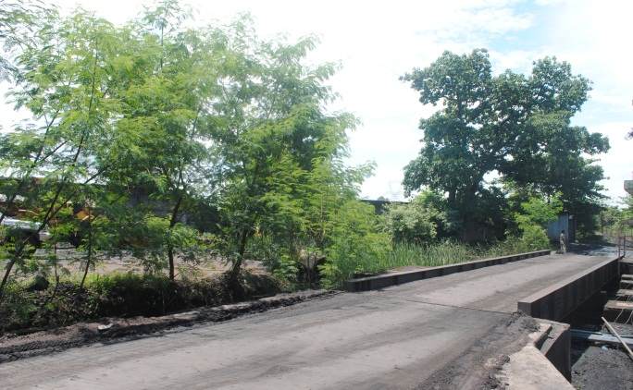

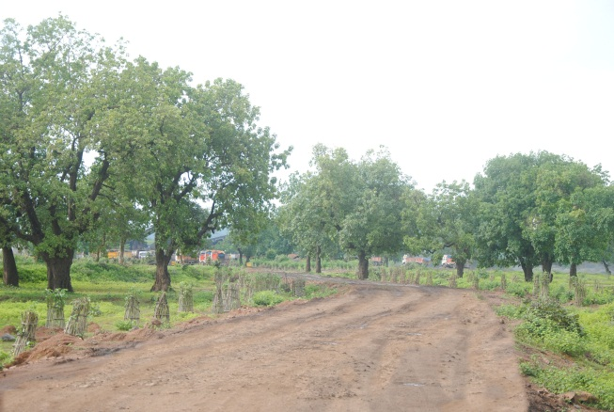
Annexure IV: CCWB LETTER
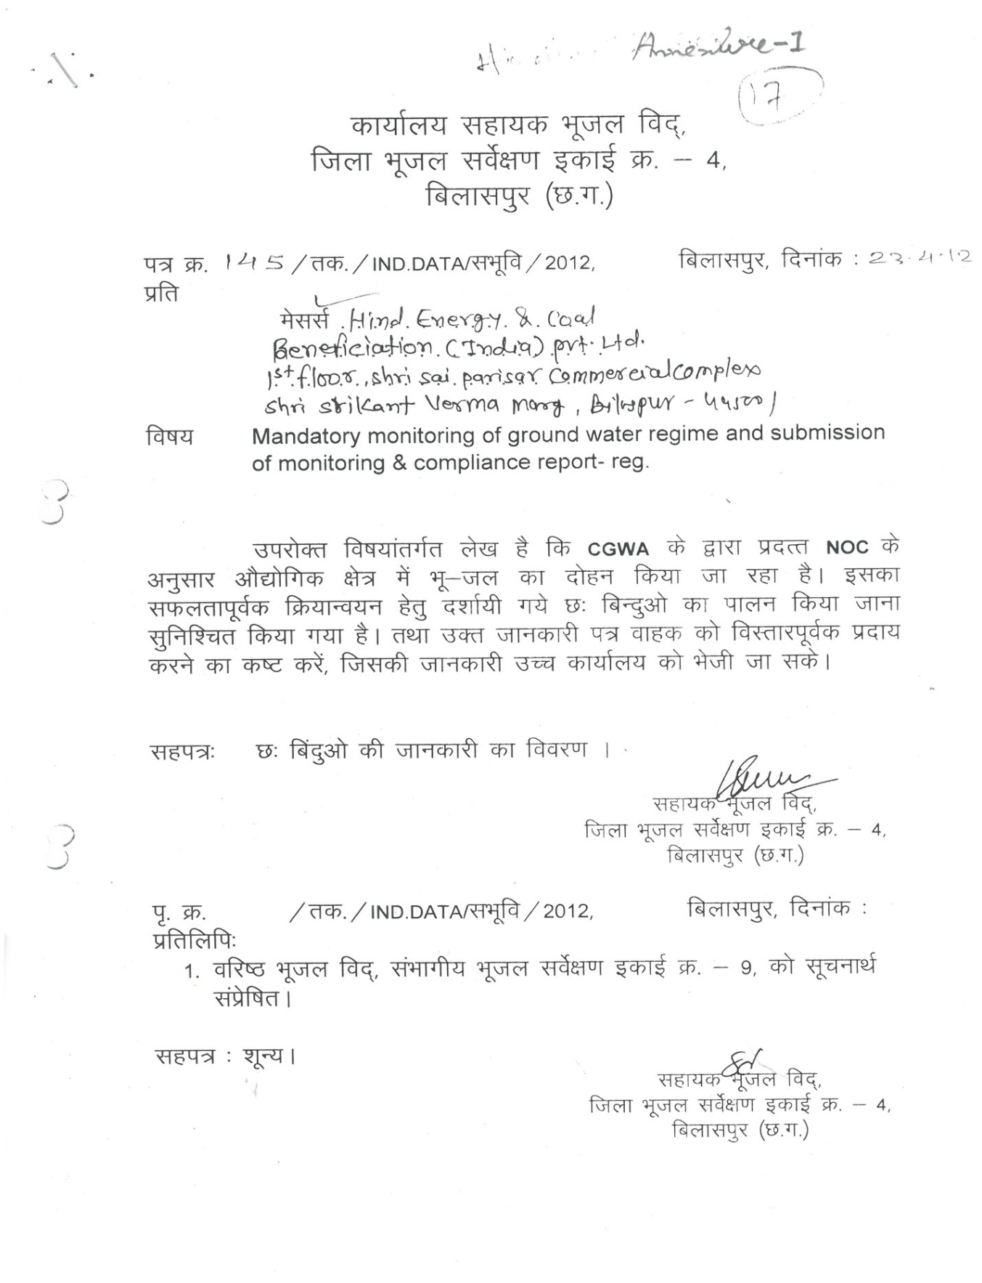
Annexure V: Plantation Programmed Carried out by HECBIL
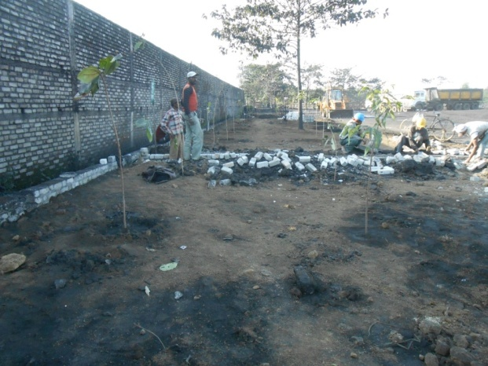

Annexure VI:Proposed Railway Siding at Gatora

Annexure VII: Paper Advisement Addressing Copy of EC Letter
EC vide letter No J-11015/190/2007-IA. II (M) dated 24/06/2008
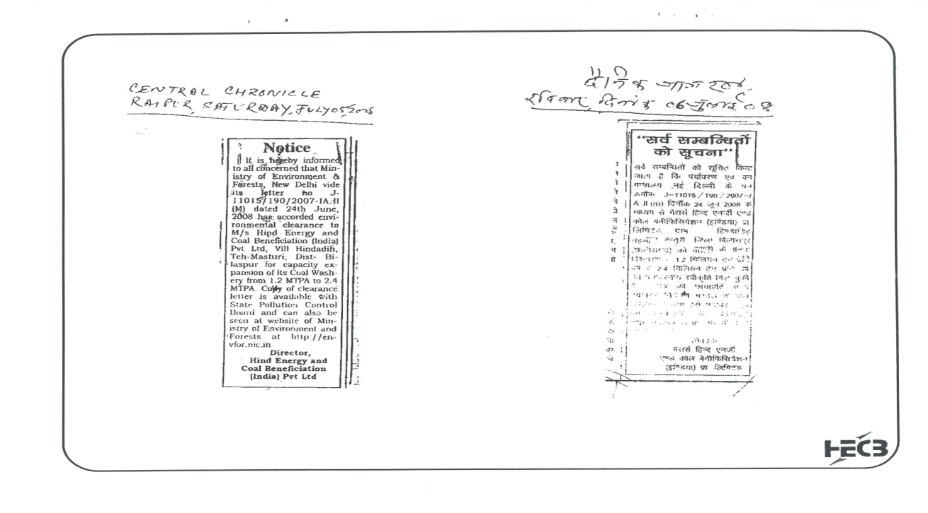
As per general condition point no:15

